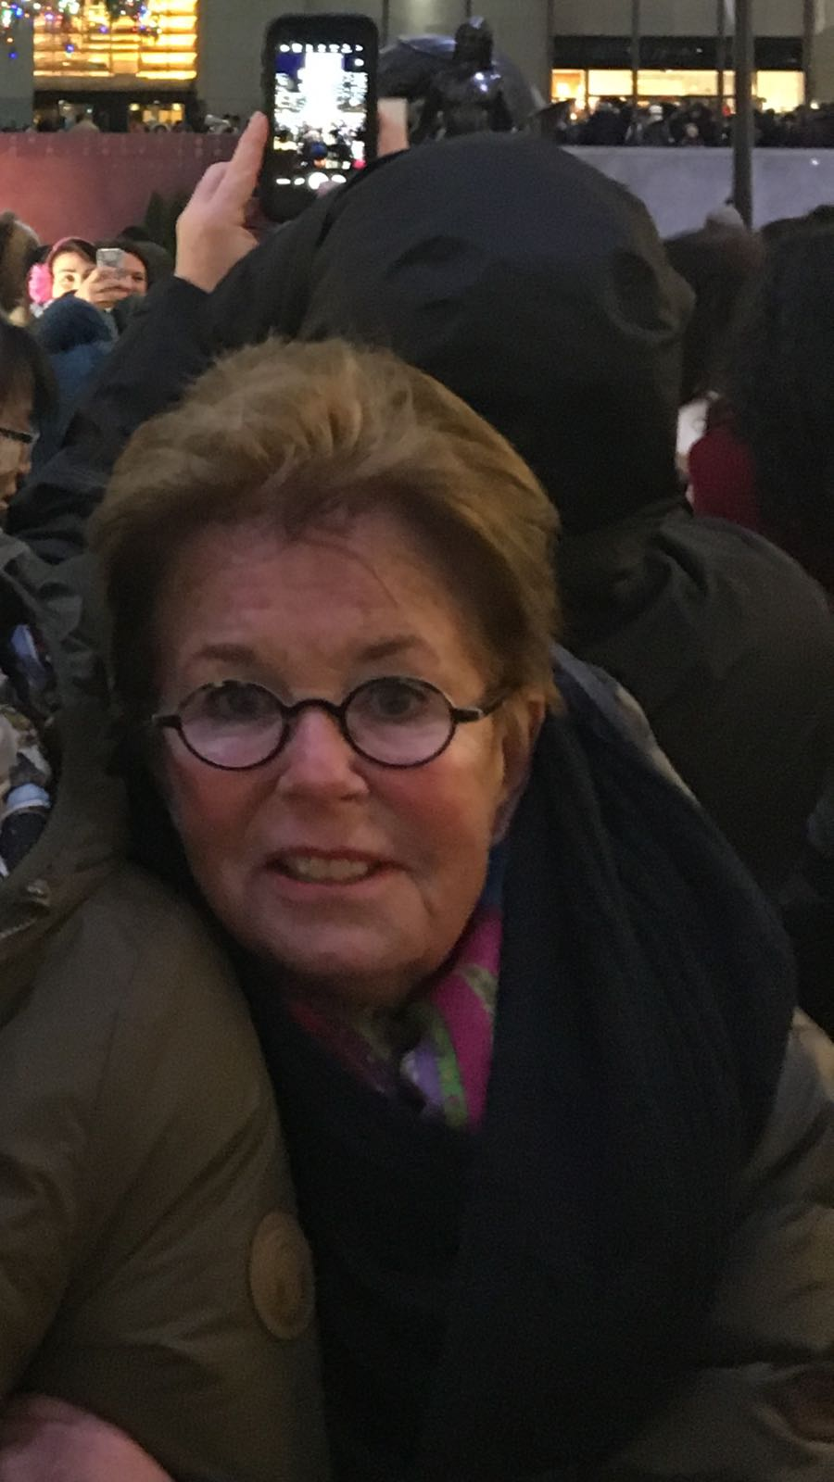
Marian Muns
Email: marianmuns@hotmail.com

